**How to register in Jira**

1. Keep in mind that this is a sample tutorial. Atlassian regularly changes some of the steps for the registration, but we assume that if you are considering exploring the QA profession, you have the basic skills to download and install software without any problems.
2. Go to [**https://www.atlassian.com/software/jira**](https://www.atlassian.com/software/jira)



1. Continue with email, google or other of the accepted profiles that you have.

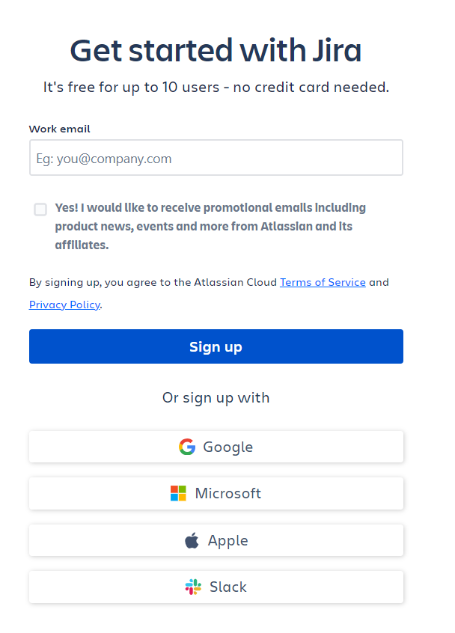

1. Depending on the way you chose to register, there will be some additional verification that you need to perform.
2. Now, that you have a profile, you have to create your site with Jira. Choose a meaningful name and follow the naming rules:  
   "Your site name must be 3 or more lowercase letters and/or numbers. Hyphens are ok if they’re in the middle."

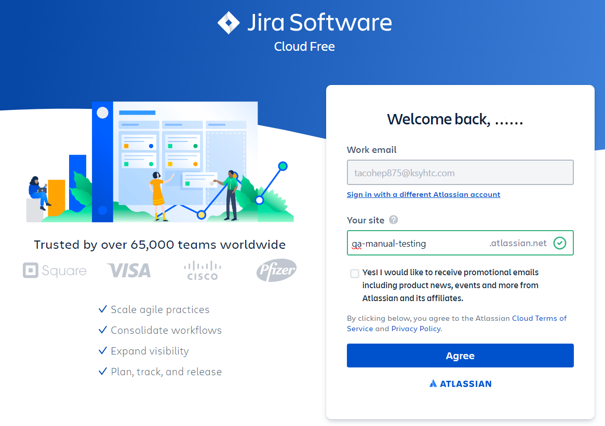

1. You can skip the following questions



1. Check "Testing and quality assurance (QA) or you can skip this question as well.

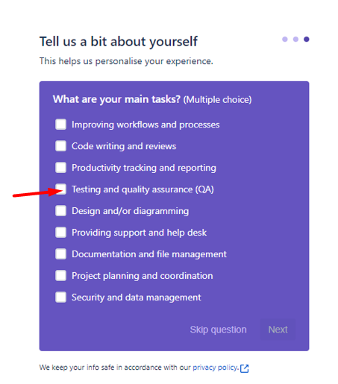

1. Give it some time to create your site.



1. Once done, you will be prompted to create a new project from Jira’s most popular templates. Since we don’t need Kanban or Scrum project, just click next.

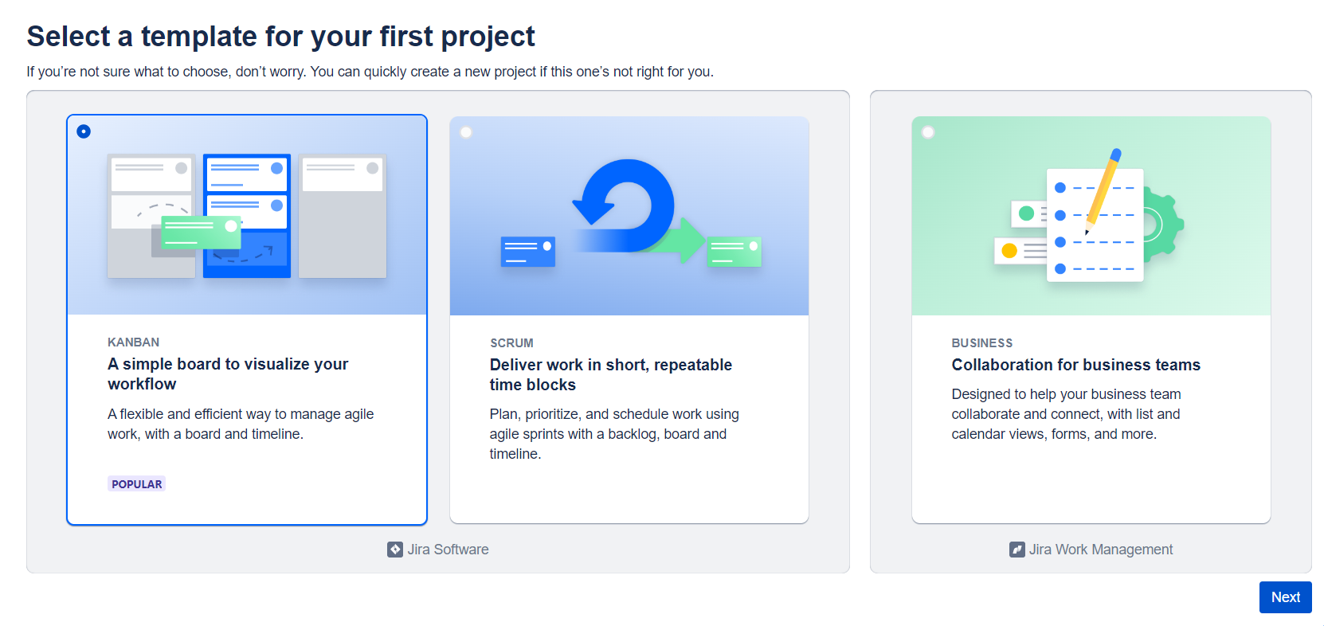

1. Jira will create a project for you and probably will offer you a tour across the project template. You can take the tour if you are interested, but the project template that we need is “Bug tracking”, so we recommend you hit the “Explore by myself” button

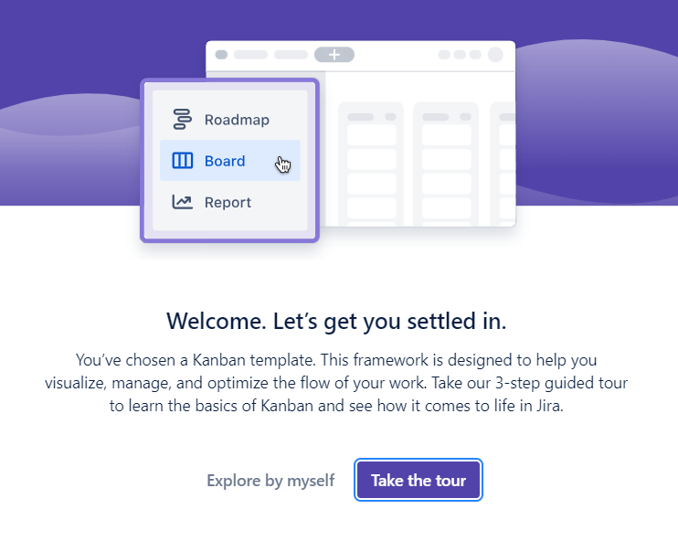

1. From the top menu, navigate to “Projects”, “Create project”.

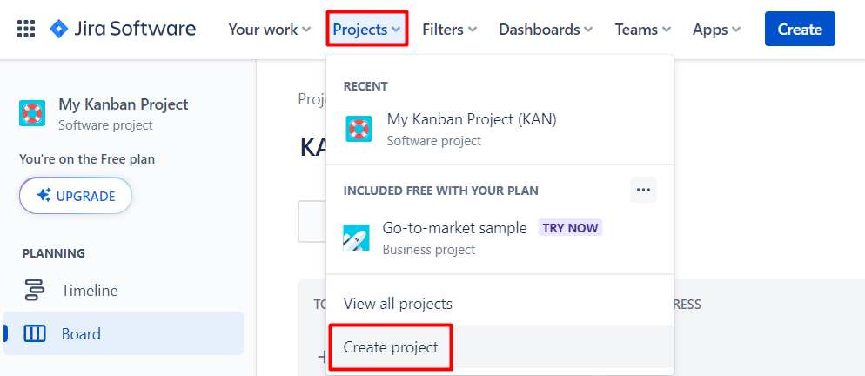

1. From the project templates choose “Software development” and then “Bug Tracking”

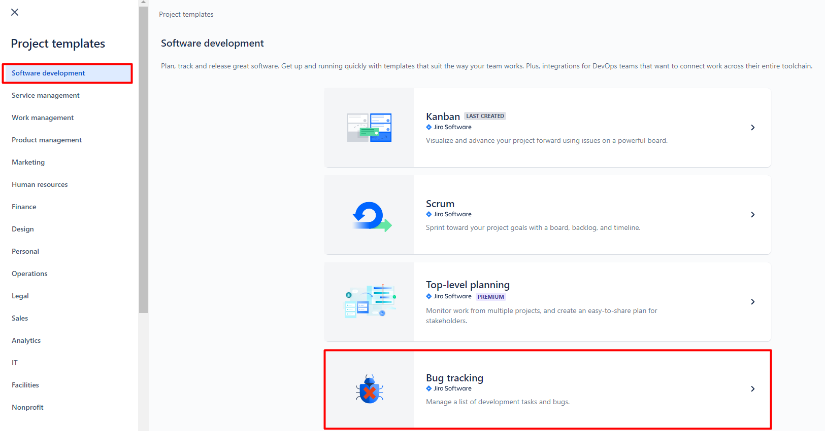

1. Confirm that you want to use the template.

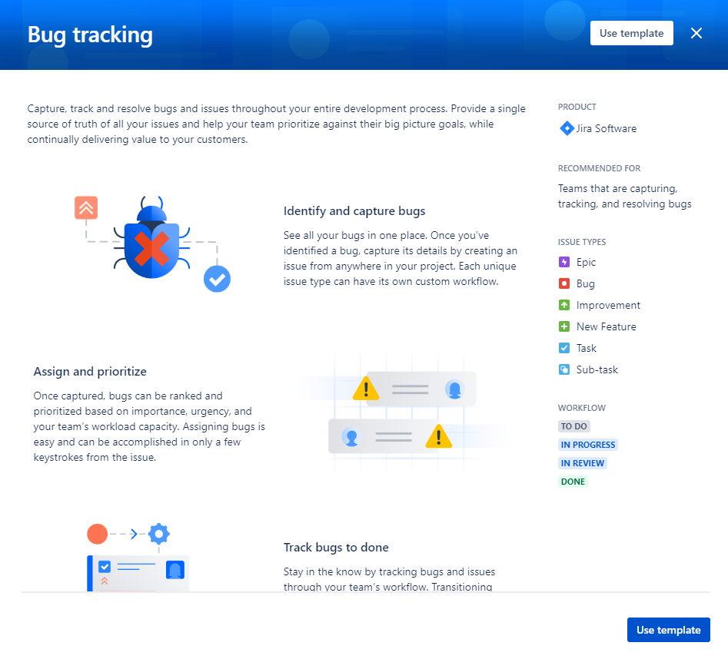

1. Now, choose a meaningful name for your project and click "Create project".

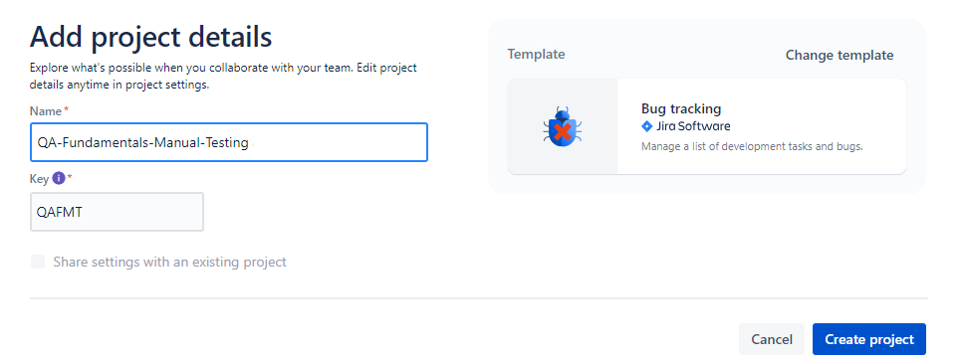

1. And your “Bug Tracking” project is ready.

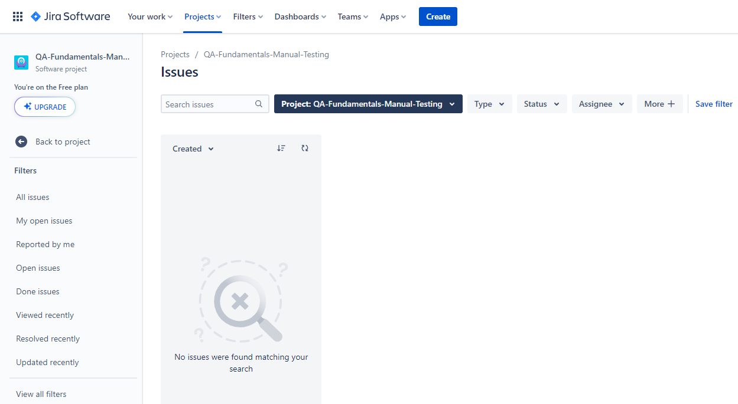

1. The next time you visit <https://www.atlassian.com/> and log in, click on the button and choose "Jira Software" to navigate to your project/s.

